IST 659 Lab 2

Part 1: Conceptual Modeling Case Studies.

Sol:

Case Study 1:

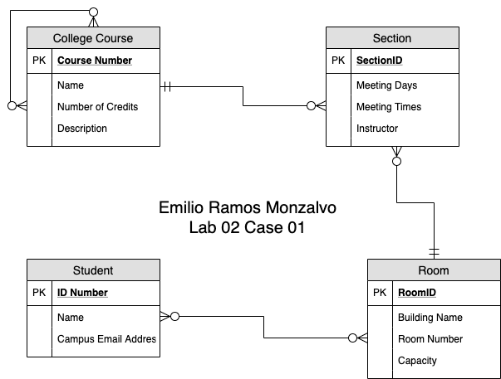

Case Study 2:

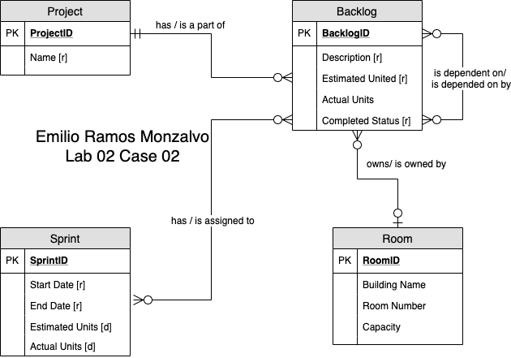

Case Study 3:

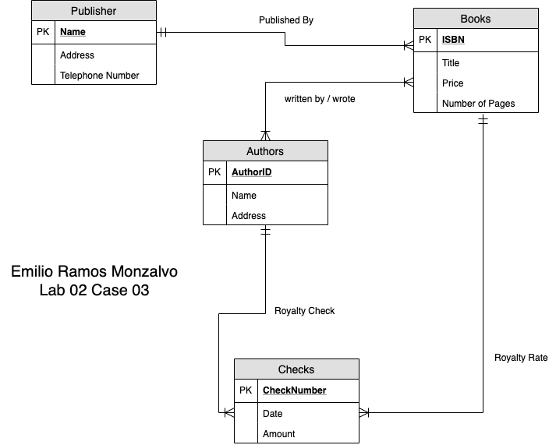

Part 2: VidCast Conceptual Model

Sol:

